**GTG Perfumes – Frontend Assignment**

**Objective**

Build a **pixel-perfect, fully responsive webpage** from the provided Figma design using **HTML, CSS, and JavaScript**, focusing on clean code, responsiveness, and interactivity.

**Tech Stack**

* HTML
* CSS
* Vanilla JavaScript (no frameworks)

**Key Highlights**

* Pixel-accurate UI based on Figma
* Fully responsive (desktop, tablet, mobile)
* Hamburger menu for smaller screens
* Interactive product gallery (arrows, dots, thumbnails)
* Functional radio selections (Fragrance & Purchase Type)
* Expandable Single & Double Subscription sections
* Animated percentage counters on scroll
* HTML comparison table
* Cross-browser compatible

**Project Structure**

/project-folder

/images

/css

/js

index.html

**FIGMA DESIGN**

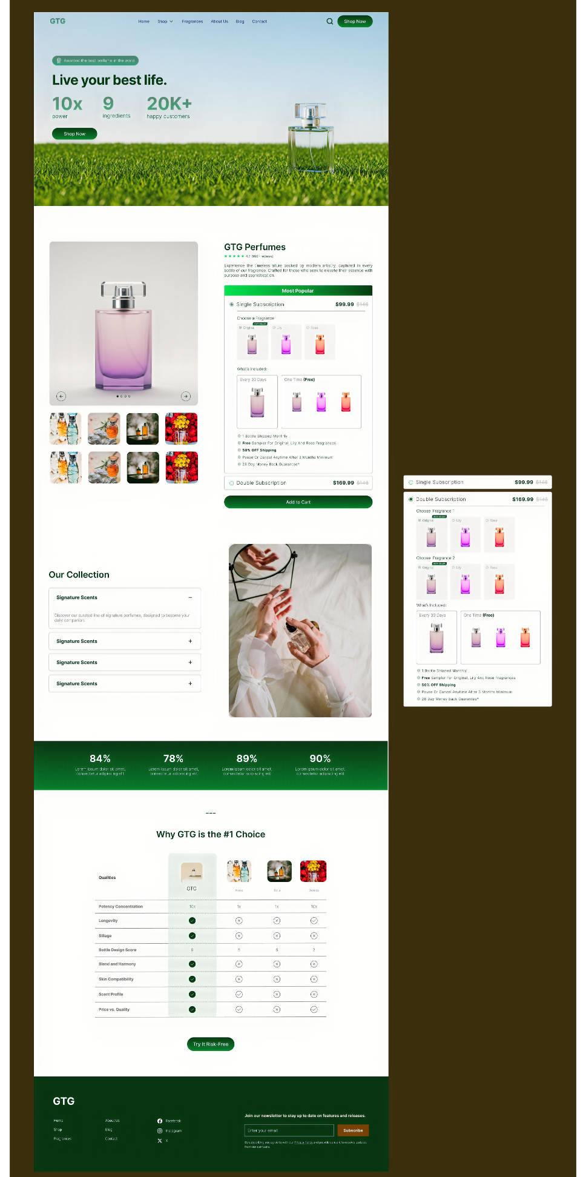

**Implementations**

